**SRI SIDDHARTHA INSTITUTE OF TECHNOLOGY**

**(A Constituent College of Sri Siddhartha Academy of Higher Education, Tumakuru,**

**Approved by AICTE, Accredited by NBA, NAAC ‘A+’ Grade)**

MARALUR, TUMAKURU – 572105, KARNATAKA

**DEPARTMENT OF COMPUTER SCIENCE AND ENGINEERING**

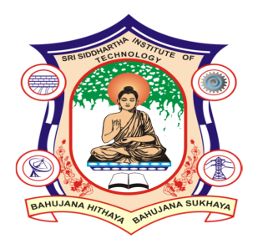

**CERTIFICATE**

*This is to certify that the laboratory entitled* ***“CSE2LB2: Machine learning lab”*** *is a bonafide work carried out by* ***MANISH H R (23CSE03)*** *in partial fulfillment for the award of degree of* ***Master of Technology*** *in* ***Computer Science and Engineering*** *during the academic year* ***2023-24****.*

*It is certified that all the corrections/suggestions indicated for internal assessment have been incorporated in the report. The Lab report has been approved as it satisfies the academic requirements in respect of Laboratory work prescribed for the degree of Master of Technology in Computer Science and Engineering.*

|  |  |
| --- | --- |
| **Signature of the faculty** | **Signature of the faculty** |
| **Dr. Raviram V** | **Dr.Asha K R** |
| M.C. A, M.Phil, M.Tech, Ph.D  Professor,  Dept. of CSE  SSIT, Tumakuru | M.C. A, M.Phil, M.Tech, Ph.D  Associate Professor,  Dept. of CSE  SSIT, Tumakuru |

**Submitted By** **USN**

**MANISH H R (23CSE03)**

**Examiners Signature with Date**

**1.**

**2.**